Cryptocurrency Analysis

(COMP3125 Individual Project)

Michael Olds   
*Wentworth Institute of Technology*

*Abstract*—Cryptocurrency has emerged as a significant asset class, with Bitcoin leading the charge in terms of popularity and market impact. This project investigates the historical trends of cryptocurrency prices, identifies the most volatile cryptocurrencies, and explores correlations between various cryptocurrencies. The study further examines the feasibility of predicting cryptocurrency prices using historical data and technical indicators. Machine learning, particularly the Long Short-Term Memory (LSTM) network, is employed for time series forecasting to predict future price movements. The research aims to provide valuable insights into the dynamics of cryptocurrency markets and the potential for predictive modeling in this volatile environment.

Keywords— cryptocurrency, Bitcoin, volatility, machine learning, LSTM

# INTRODUCTION

# Cryptocurrency has rapidly gained popularity and is increasingly being recognized as an alternative form of currency alongside traditional actual money. The growing interest in digital assets has led to significant market fluctuations and a dynamic trading environment. This project aims to analyze historical trends in cryptocurrency prices, identify the most volatile cryptocurrencies, and explore the relationship between global events and cryptocurrency prices. Additionally, the study will focus on predicting cryptocurrency prices based on historical data and technical indicators using machine learning models.

# Datasets

## Price History Dataset:

## This dataset provides historical price movements of various cryptocurrencies (Bitcoin was chosen as it is the most popular Cryptocurrency), available at [Kaggle](https://www.kaggle.com/datasets/sudalairajkumar/cryptocurrencypricehistory).

## All Cryptocurrencies Dataset:

# This dataset includes a comprehensive list of cryptocurrencies and their attributes, available at [Kaggle](https://www.kaggle.com/datasets/jessevent/all-crypto-currencies).

## Cryptocurrency Pairs Dataset

This dataset offers minute-resolution data on cryptocurrency pairs, available at [Kaggle](https://www.kaggle.com/datasets/tencars/392-crypto-currency-pairs-at-minute-resolution).

The All Cryptocurrencies Dataset, as well as the Cryptocurrency Pairs Dataset contained too many files so the data needed to be narrowed down to fit properly. This was done using excel. For the All Cryptocurrencies Dataset, I managed to delete data from very small cryptocurrencies that had very little volume and a very low market cap. For the Cryptocurrency Pairs Dataset, there were many different csv files, this meant getting meaningful data would be difficult, so I decided to go with a Bitcoin pairs dataset, as Bitcoin is the most popular cryptocurrency that almost everyone knows of.

# Methodology

This study will address four key research questions:

## What are the historical trends of cryptocurrency (Bitcoin) prices?

## Data analysis was performed using line charts to visualize historical price trends. Moving averages were also used to show bullish and bearish runs throughout the coins’ history.

## Which cryptocurrencies have the most volatility?

Standard deviation of daily returns was used to measure volatility across different cryptocurrencies. A bar chart was created to visualize the top 10 most volatile cryptocurrencies.

## How do different cryptocurrencies correlate with each other in terms of price movements?

## Correlation matrices will be used to evaluate the relationships between different cryptocurrency price movements.

## Can we predict the price of a cryptocurrency based on historical data and technical indicators?

A machine learning model, specifically a Long Short-Term Memory (LSTM) network, will be used for time series forecasting.

By analyzing these aspects, this project aims to provide insights into cryptocurrency market behavior and the feasibility of predicting future price movements based on historical trends and other influences.

# Results

## In this section, we present findings from the four key areas investigated: historical price trends, volatility analysis, correlation among cryptocurrencies, and price prediction using machine learning. Visualizations such as line graphs, bar charts, heat maps, and prediction plots are used to illustrate the outcomes.

## Historical Price Trends of Bitcoin

#### To understand long-term patterns in Bitcoin’s history, a line chart of daily closing prices was created. Trends such as the Bull Runs in 2017 and 2021 are very apparent here. Moving averages were also visuallized to indicate bullish or bearish movements in the price.

Bitcoin Price History, in Blue
1-Month Average in Green
1-Year Average in Red

## Volatility of Cryptocurrencies

The standard deviation of daily returns was calculated for multiple different cryptocurrencies to determine the volatility of the coin. A bar chart was then used to visualize the top 10 most volatile cryptocurrencies. Based on this graph, small-market coins such as Zcash and Hubbi Token are by far the most volatile. Then what follows are more renowned cryptocurrencies which include the likes of Bitcoin and Ethereum.

## Correlation Between Cryptocurrencies

A correlation matrix was generated to determine how closely different cryptocurrencies move together with the help of many response variables. From the heatmap generated from the correlation matrix, variables like open price, high price, low price, and close price all contribute to the value of a coin equally as well. On the other hand, variables like close ratio and daily return price have very weak correlations to the price of a cryptocurrency, showing that these variables are somewhat irrelevant.

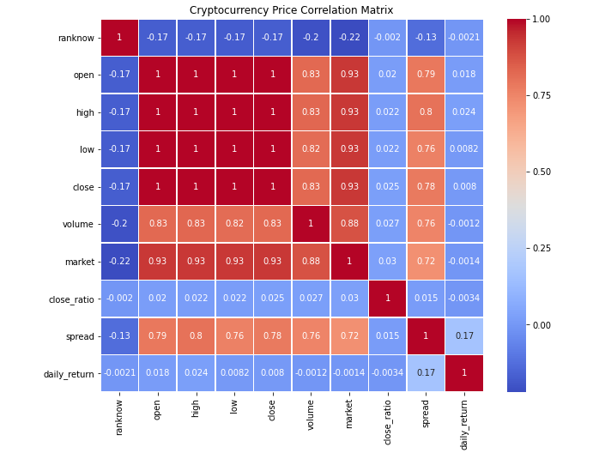

## Cryptocurrency Price Prediction with LSTM

An LSTM Neural Network was trained on historical Bitcoin price data. The model was generally able to capture general trends but struggled when there were high points of volatility in the coin. While the prediction followed the overall direction of the prices, it was not 100% accurate. The future predictions take into account previous data, and from the current trends, the prediction believes Bitcoin to plummet to approximately $20,000.

# Discussion

One part of this project that seems inconclusive is the prediction made by LSTM. Realistically, the prices of Bitcoin would never dip as far down as the graph predicts, however, since this method of machine learning only takes into account recent data, it can cause errors in prediction like the one seen. In the future, different machine learning models can also be used to find a prediction that looks more accurate to what the price of Bitcoin will actually follow.

# Conclusion

This project provided a comprehensive analysis of cryptocurrency markets, focusing on historical trends, volatility, correlations, and price forecasting. The results showed that while Bitcoin continues to dominate in popularity and influence, smaller market-cap coins such as Zcash and Hubbi Token exhibit significantly higher volatility.

Correlation analysis revealed that standard price indicators (open, high, low, close) are consistently interrelated across coins, whereas metrics like close ratio and daily return price offer limited predictive value.

The LSTM model was able to capture general price direction but fell short in periods of high volatility, leading to unrealistic predictions like a dramatic drop to $20,000. This highlights both the potential and limitations of machine learning in highly volatile markets. Future studies could benefit from hybrid models or the inclusion of broader market indicators such as trading volume, global economic factors, or social media sentiment.

Overall, this research confirms the complex and dynamic nature of cryptocurrency markets and underscores the importance of combining statistical and machine learning approaches for deeper insight and more reliable forecasting in financial technology.

##### References

1. “Cryptocurrency Historical Prices,” *www.kaggle.com*. https://www.kaggle.com/datasets/sudalairajkumar/cryptocurrencypricehistory
2. ‌Carsten, “400+ crypto currency pairs at 1-minute resolution,” Kaggle.com, 2023. https://www.kaggle.com/datasets/tencars/392-crypto-currency-pairs-at-minute-resolution (accessed Apr. 10, 2025).
3. jvent, “Every Cryptocurrency Daily Market Price,” Kaggle.com, 2017. https://www.kaggle.com/datasets/jessevent/all-crypto-currencies